


Date | Activity | Time | Activity Location | Movie Location  & Time
Parents: Please note it is important to register your child for craft activities on the day of the activity,
We are unable to pre-book prior to the day. Our craft activities are capped at 50.
Sat 19 Sept | Movie |  |  | Check whiteboard for movie location and time
Sun 20 Sept | Plaster Painting  Movie | 2:30-3:30pm | Camp Kitchen area | Check whiteboard for movie location and time
Mon 21 Sept | Movie |  |  | Check whiteboard for movie location and time
Tue 22 Sept | Beading Day – necklaces/bracelets | 2:30-3:30pm | Camp Kitchen area
Wed 23 Sept | Neoprene Key Tags  Movie | 2:30-3:30pm | Camp Kitchen area | Check whiteboard for movie location and time
Fri 25 Sept | 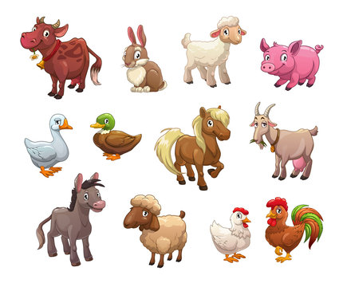  Baby animal zoo will be here this morning  Lanyard decorating  Movie | 10:00-12:00pm  2:30-3:30pm | *see whiteboard  Camp Kitchen area | Check whiteboard for movie location and time
Sat 26 Sept | Goal kicking competition 11:00–12:00pm Camp Kitchen area  AFL Grand Final Day  The game will be played on the big screen on the riverfront from 11:00am
Sun 27 Sept | Dream Catchers | 2:00-3:00pm | Camp Kitchen area

Hey kids, there are also a variety of fun activity sheets and colouring sheets available at Reception for you to do while you are here.
We have some board games which will require a $20 deposit.
All our craft activities are free!
~ We hope you make some new friends and enjoy your holidays at BIG4 Deni ~




Date | Activity | Time | Activity  Location | Movie Location  & Time
Parents: Please note it is important to register your child for craft activities on the day of the activity,
We are unable to pre-book prior to the day. Our craft activities are capped at 50.

Mon 28 Sept | Beading | 2:00-3:00pm | Camp Kitchen area
Tue 29 Sept | Movie |  |  | Check whiteboard for movie location and time
Wed 30 Sept | Badge making  Movie | 2:00-3:00pm | Camp Kitchen area | Check whiteboard for movie location and time
Fri 2 Oct | Baby animal zoo will be here this morning  Fuzzy art colouring / neoprene keyrings  Movie | 9:00-11:00am  2:00-3:00pm | *see whiteboard  Camp Kitchen area | Check whiteboard for movie location and time
Sat 3 Oct |   Perler beads  Movie | 2:00-3:00pm | Camp Kitchen area | Check whiteboard for movie location and time
Don’t forget ….
Daylight Savings begins tonight, we lose an hours sleep!
Sun 4 Oct | Movie |  |  | Check whiteboard for movie location and time
Hey kids, there are also a variety of fun activity sheets and colouring sheets available at Reception for you to do while you are here.
We have some board games which will require a $20 deposit.
All our craft activities are free!
~ We hope you make some new friends and enjoy your holidays at BIG4 Deni ~

